**EXPERIMENT NO – 07**

Title: Ruby Installation and setup.

**Installation & setup.**

Step1: open browser and search “ruby-lang.org”.

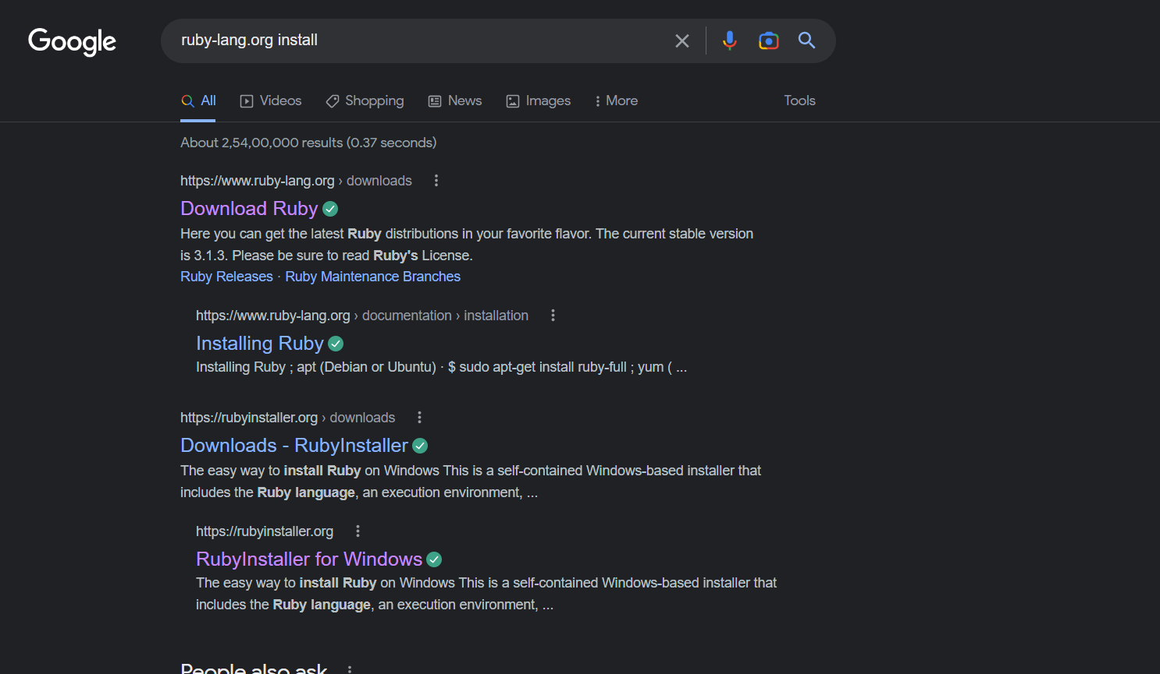

Step2: click on “ruby installer”

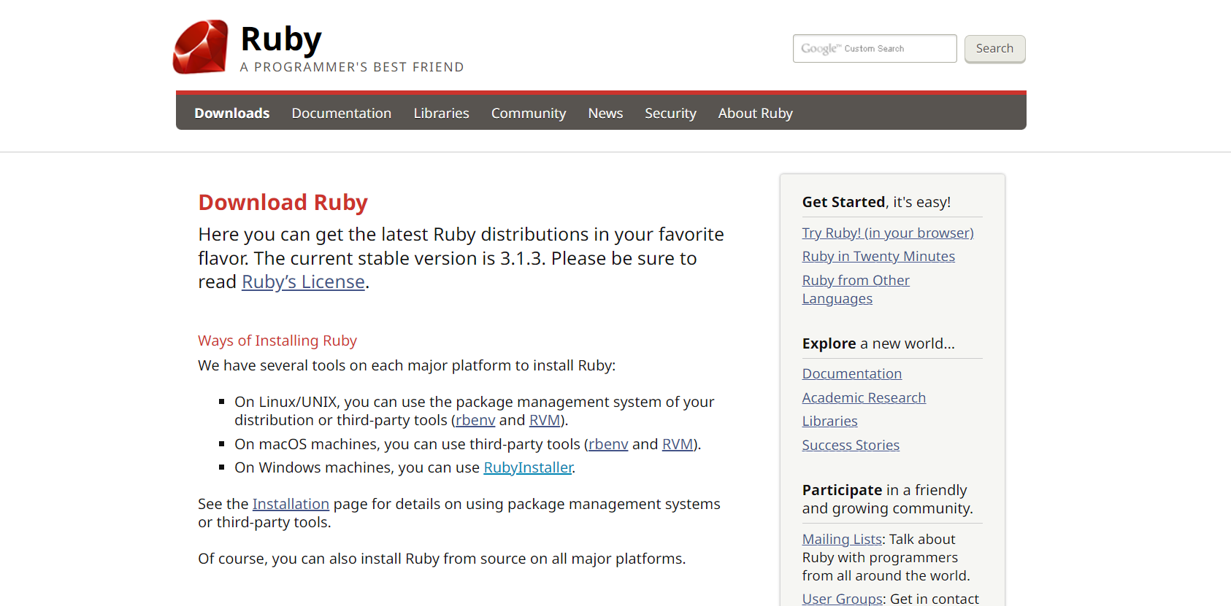

Step3: Download ruby with devkit. (32 or 64 bit version)

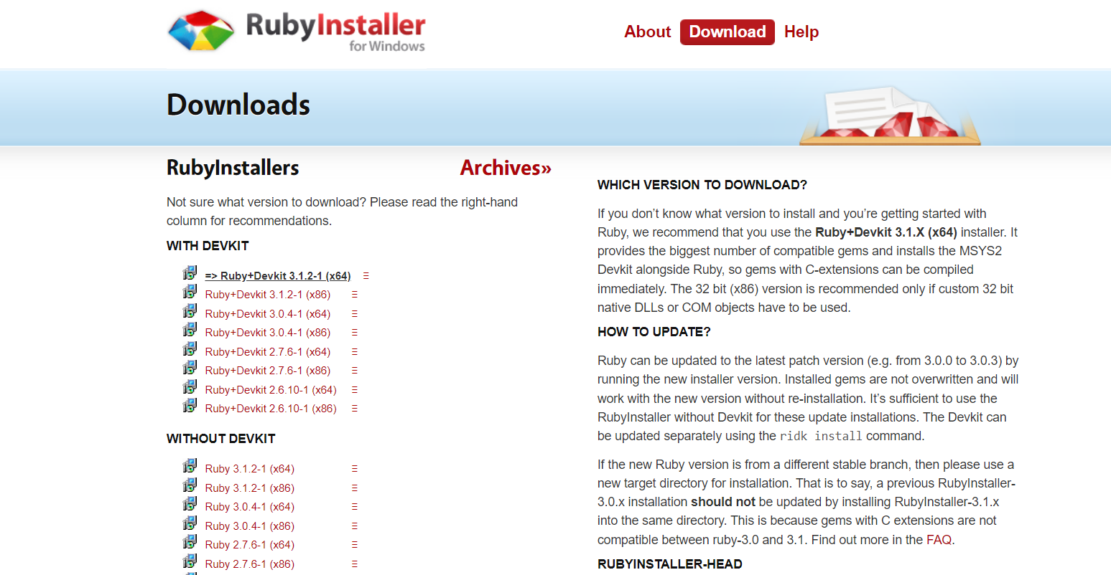

Step4: download and open it, accept the license to start installation.

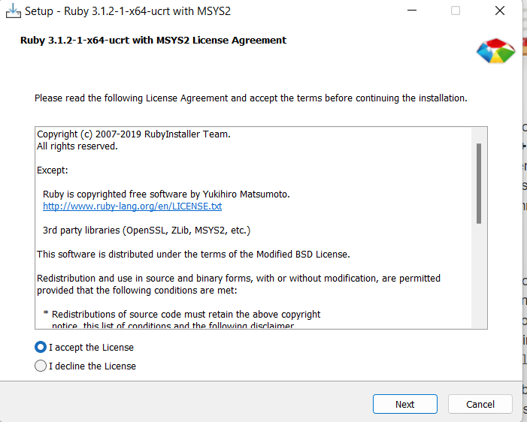

Step5: set where you want to install ruby.

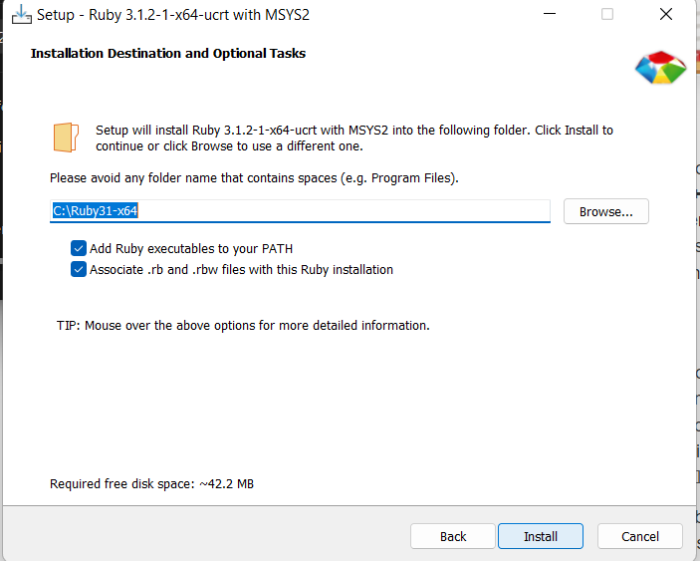

Step6: finish the installation.

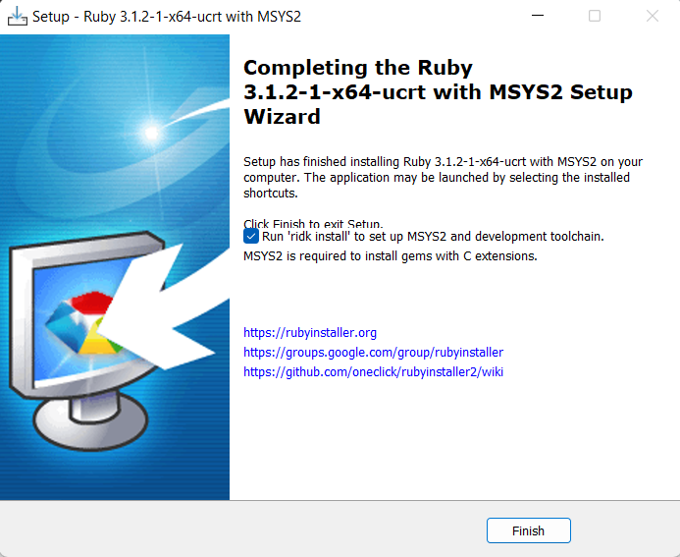

Step7: Terminal will open automatically, enter 3 and hit enter tab.

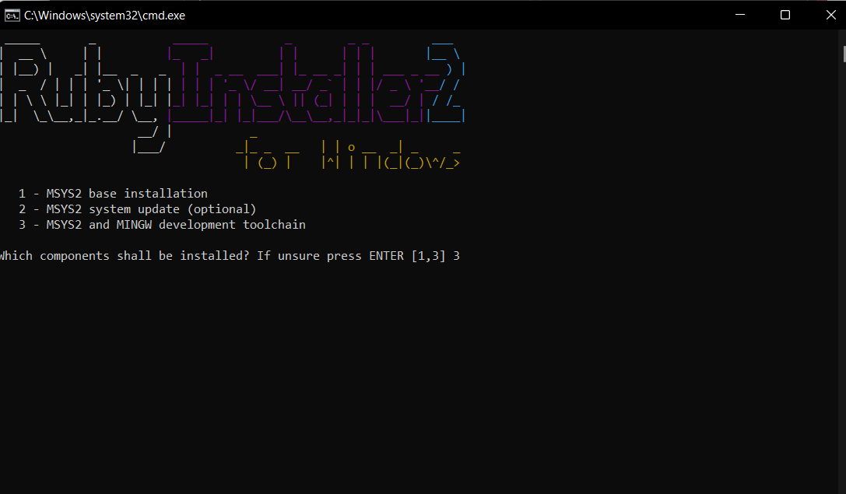

Step8: after successful installation go in directory where you have installed ruby. (go inside bin folder and copy path)

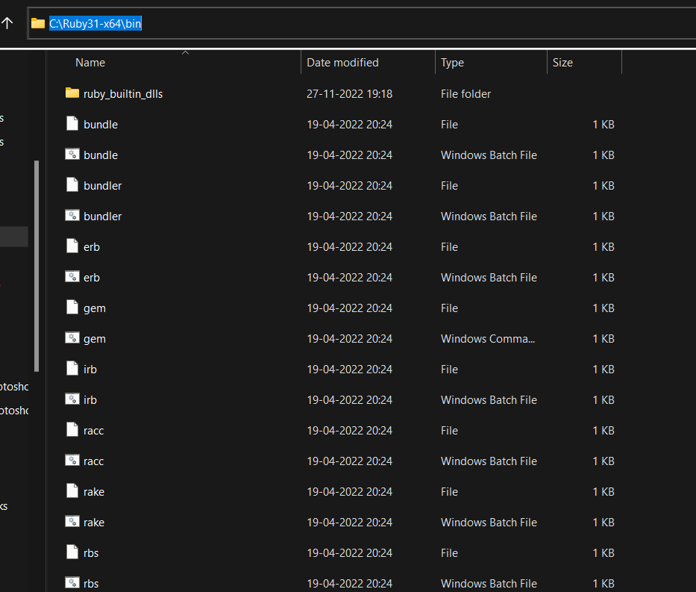

Step 9: pest it “environment variables>>system variables>>path>>edit>>new” click “ok”.

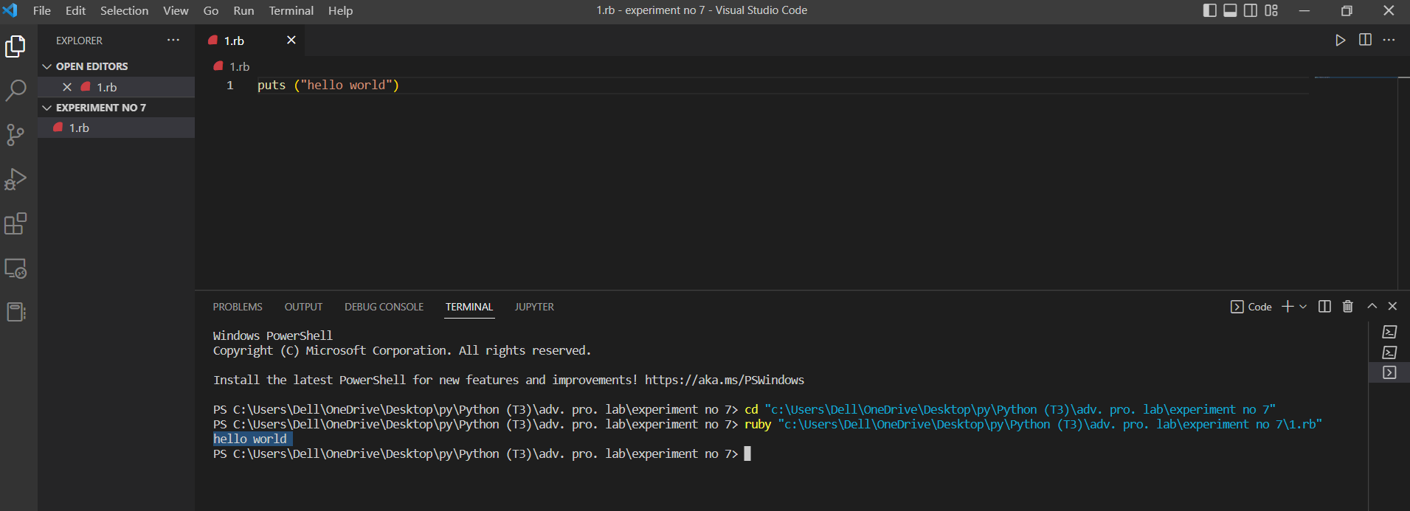

Getting started with ruby.

